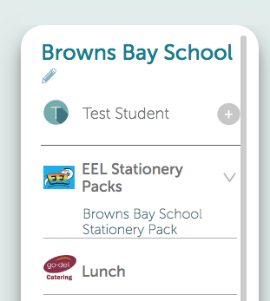
Stationery packs online

Not only can you make school payments, support fundraisers, and order school lunches, you can also order your 2023 Stationery Packs from our Kindo school shop too!
It’s easy, convenient, and open 24/7.

Create your family account

It’s easy to set up your family account.
Click here for the login page OR visit www.mykindo.co.nz.
New Users can click on and complete the online registration form with your contact details and your child/ren’s name/s.
Existing users can simply login and place your order.

Topping up your account

There are a number of ways you can choose to top-up your account. This can be done at the checkout, or my selecting the ‘top up account’ icon.

Bank Transfer No fees. Allow 2 days for processing.
POLi No fees. Instant transfer. **RECOMMENDED**
Credit/Debit Card 50 cent charge + 2.5% fee. Instant transfer.
Visa / MasterCard / American Express and China UnionPay available.

Shopping

Items can be added to your shopping cart, by clicking on your child’s initial next to an item.

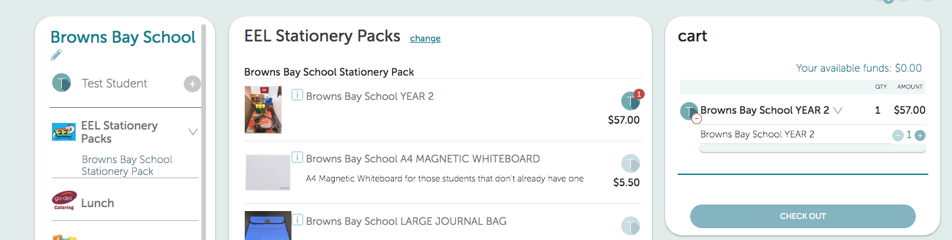
Once you have made all your purchases click on to complete your transaction.
Then simply click at the checkout and you’re done!

If you have insufficient funds you will be required to top-up first to complete your transaction.
Your order will automatically go through to Educational Essentials, and you will receive an email receipt confirming your order and/or top-up!

See it in action
You can view our short online tutorial to see how to make your purchases – Online Tutorial

Need assistance? Call the Kindo helpdesk on free phone 0508 4 KINDO (0508 454 636), or
email hello@mykindo.co.nz.

